高等電機理論 Advanced Electric Machine Theory
Homework#1
Due:9/20(五)

Problems 15. 17. 18. 19 of Chapter 1

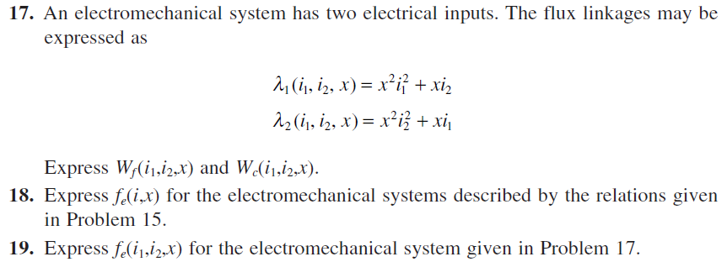

Please hand in your homework to TAs at EECS 103 or EECS 503.

